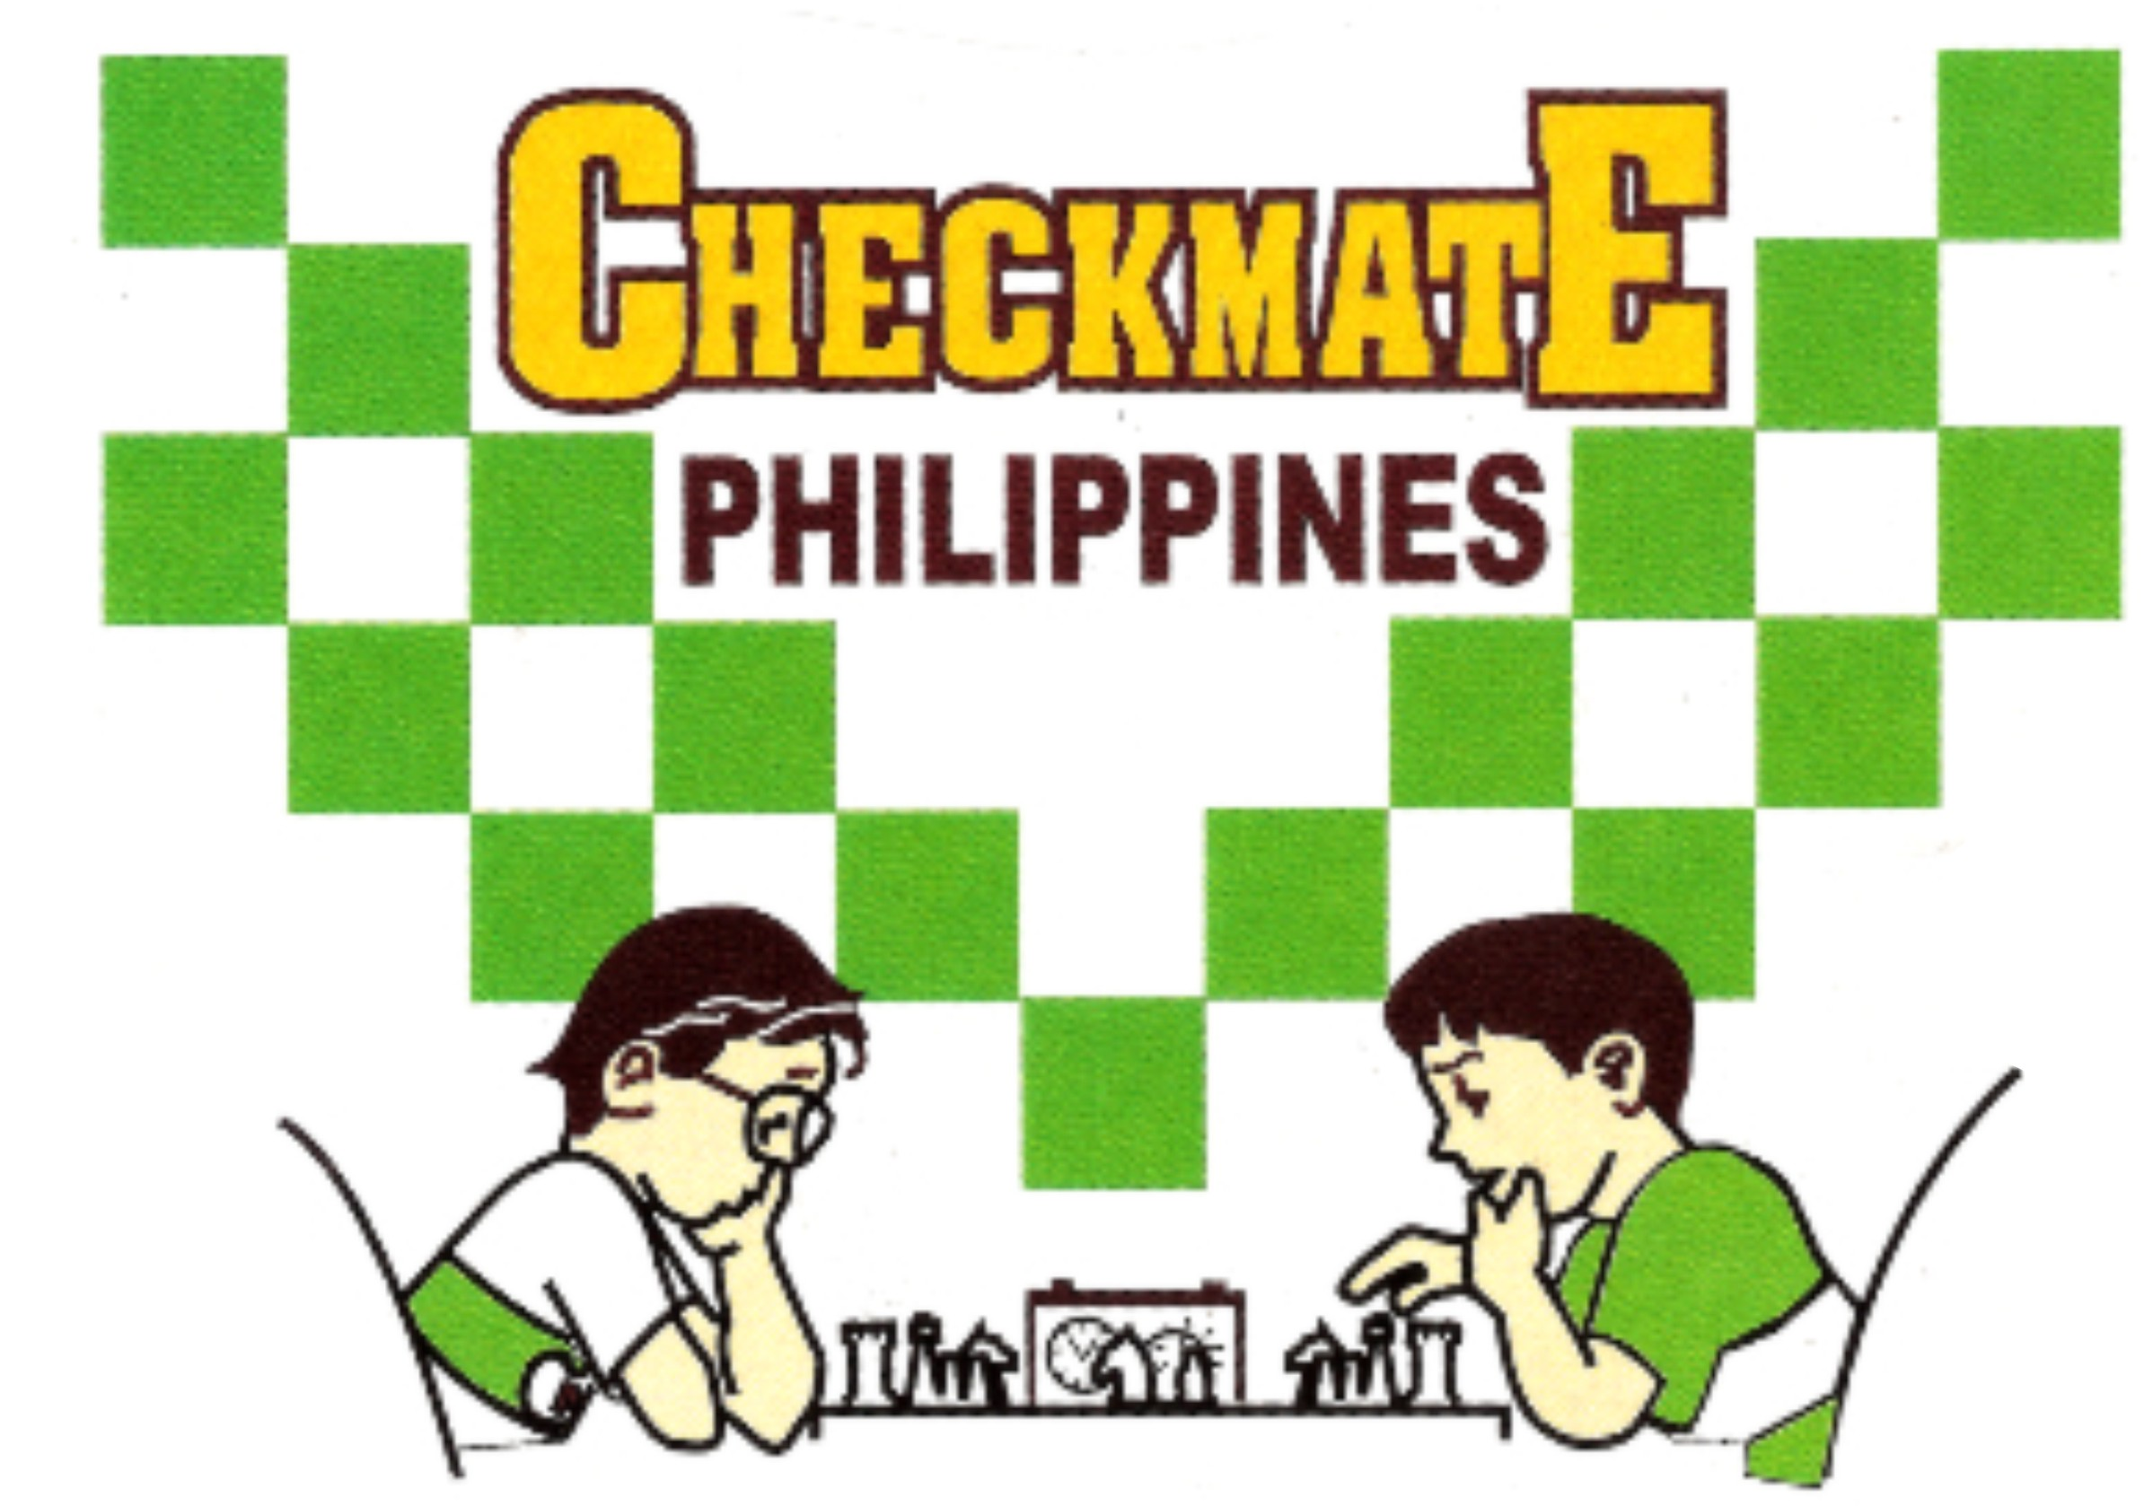 |  | PSA LIFETIME ACHIEVEMENT AWARDEE: SCOOP AWARDEE METROPOLITAN CHESS CENTER  Office: 834 Marquez St., Ph. 5 Gatchalian Subd., Las Piñas City  Landline: (02)-8826-8560 Mobile no. 0922-822-6319  email: mccchess@yahoo.com website: mccchess.com  fb: milo checkmate chess clinic and sports academy

Registration Form for MCC Fide-rated Standard 1800 Below Tournament

Please fill-up the form completely. Email the filled-up form together with your deposit slip at mccchess@yahoo.com.

FULL NAME: FIDE Rating NCFP Rating MCC Rating

_______________________________________________________________________________________________________________
ADDRESS Email

CONTACT NO. BIRTHDATE AGE GENDER

_______________________________________________________________________________________________________________
SCHOOL/OFFICE HS/COLLEGE/POSITION

_______________________________________________________________________________________________________________
CHESS AWARDS (IF ANY)

Declaration:

By joining this chess activity, I/We hereby certify that the organizer(s) and its staff are not responsible for any damages, loss, or injury which I/We may be sustained by the player during the course of the event or may arise from any cause in connection with the event.

_______________________________________________________________________________________________________________
PARTICIPANT’S SIGNATURE PARENT/GUIDANCE SIGNATURE
(OVER PRINTED NAME)

Details:
- Open to all untitled players and invited masters, regardless of ages and gender, and of good standing with MCC. The event is non-rated. Fide Standard ratings will be used for ranking purposes only.
- Venue: 3/F Starmall Edsa Shaw in Mandaluyong. Time: 10am-7:30pm.
- Round 1 start at 10:10am. Defaulting time is 30 min. after the announcement of the starting time.
- Number of Rounds: seven (7). Time control: 40 min. with two (2) seconds increment.
- Entry fees: P400 - Milo Checkmate current enrollees and masters and P500- for others. Can pay thru gcash 0922-822-6319 or BDO acct# 001480-1353-70 both under Milagros Emperado.
- Registration is online and can be done thru social media like fb, messenger or viber. NO ONSITE REGISTRATION. Your registration is confirmed once you receive an acknowledgement thru text or messages.
- Objective of the event: to revive playing with more time as it helps players to practice and refine their mental processes required during analysis which leads to greater precision and speed in recognizing and providing solutions for certain positions. No offence meant to organizing big events using the quick time control. The MCC has been organizing classical tournaments since it was founded on March 1988.

